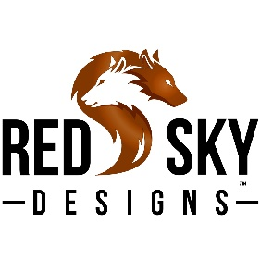 Red Sky Desings, Inc.
Custom / Bulk / Wholesale Order Request:
Customer Name: Date:
Beverage Holder Style and Color:
Please put an “X” next to the style (s) you are interested in.
Beer Bottle:
Can:
~Standard Size:
~COORS® Size
Skinny Can:
16 oz Tall Boy/Water Bottle:
Pint:
Flask:
Wine Bottle:

Bison Leather Color(s):_______________________________________________

Natural Cowhide Color(s): ____________________________________________

Animal Print or Acid Wash Color(s):____________________________________

Customization Request (if applicable):
Please add any applicable details regarding your custom laser engraving request below.
If you have an image or logo, please remember to attach it to the email with this request.
*** We cannot laser engrave any images or logos unless you own the rights to the image/logo.
_______________________________________________________________________________________________________________________________________________________________________________________________________________________________________________________________Bulk Quantity Requested : ________________________ Date needed by:__________________
Company Name, if applicable:_________________________________________
Phone # if you would like us to call you: ________________________________
Email this form, or a detailed request including all of the above information to: lori@redskydesigns.com
You are also welcome to call us with your request at 406-861-1962 – We are located in Montana.
We will review your customization/ bulk or wholesale order request and get back with you with a detailed custom quote or with any questions or clarifications needed. If you would prefer us to call you, please include your phone number.

Thank you very much for your interest in our Custom Laser Engraved Beverage Holders
Lori and Tim

